**TRIBHUVAN UNIVERSITY**

**FACULTY OF HUMANITIES AND SOCIAL**

**SCIENCES**



Nagarjuna College of Information Technology

Sankhamul, Lalitpur

**Project Work of Python on Quiz App**

**Submitted by: Submitted to:**

Sujal Maharjan Rajad Shakya

Miken Maharjan

Alex Maharjan

Bishesh Rajkarnikar

**Acknowledgments**

We would like to express our sincere gratitude to Rajad Shakya sir for his invaluable guidance, support, and mentorship throughout the development of python course. His expertise in web development, insightful feedback, and dedication to helping me overcome challenges have been instrumental in bringing this project to fruition.

Rajad Shakya sir’s deep understanding of Django, Bootstrap, and modern web development practices has enriched our learning experience and empowered use to create a user-friendly and aesthetically pleasing application. His patient and comprehensive explanations have provided clarity in complex concepts and inspired us to strive for excellence in every aspect of the project.

We extend our heartfelt thanks to Rajad Shakya Sir for sharing his knowledge generously and encouraging us to explore innovative solutions. His mentorship has not only contributed to the success of the Restaurant Menu App but has also enriched our journey as a developer.

Once again, thank you, Rajad Shakya, for your unwavering support and commitment to nurturing the next generation of developers.

Sincerely,

Sujal Maharjan

Miken Maharjan

Alex Maharjan

Bishesh Rajkarnikar

**Top of Form**

**Project Title:** Quiz App

**Description:**

The Quiz App is a user-friendly web application designed to manage and display the menu items of a fun activity in an organized and visually appealing way. This app provides Quiz host and administrators with a platform to easily add, update, and delete questions with answer with proper analysis, allowing users to have a better understanding of there performance with an engaging manner.

**Features:**

1. **Responsive Design:** The app is built with responsiveness in mind, ensuring that the questions are displayed appropriately on various devices, including desktops, tablets, and smart phones..
2. **Easy question Management:** The app includes an intuitive user interface for administrators to manage their questions. They can easily add question or remove question that are no desired.
3. **Stylish Styling:** The app utilizes modern and clean styling, with a consistent color palette and typography that enhances the overall user experience. Styling is applied to both the main page and the individual details page.
4. **Sticky Navigation:** The navigation bar remains at the top of the screen as users scroll down the page, ensuring easy access to question and the "Add question" option.
5. **Interactive Buttons:** The app features interactive buttons for actions such as selecting answers and submit for submitting answers. These buttons provide a seamless user experience.

**Purpose:**

The Quiz App aims to provide an elegant solution for quiz contest to effectively conduct their activities and manage the questions. By offering a user-friendly interface and aesthetically pleasing design, the app enhances the quiz online presence and provides a positive user experience for users exploring the app..

Whether it's a fine-dining establishment, a school, a university or a café, the Quiz App offers a versatile and adaptable platform to present their program to the users.

**Technologies Used:**

* Django: A powerful web framework for building dynamic web applications.
* Bootstrap: A popular front-end framework for creating responsive and stylish user interfaces.
* HTML and CSS: Used to structure and style the web pages.
* PostgreSQL (Optional): A robust relational database system for data storage.

**Program flow chart**

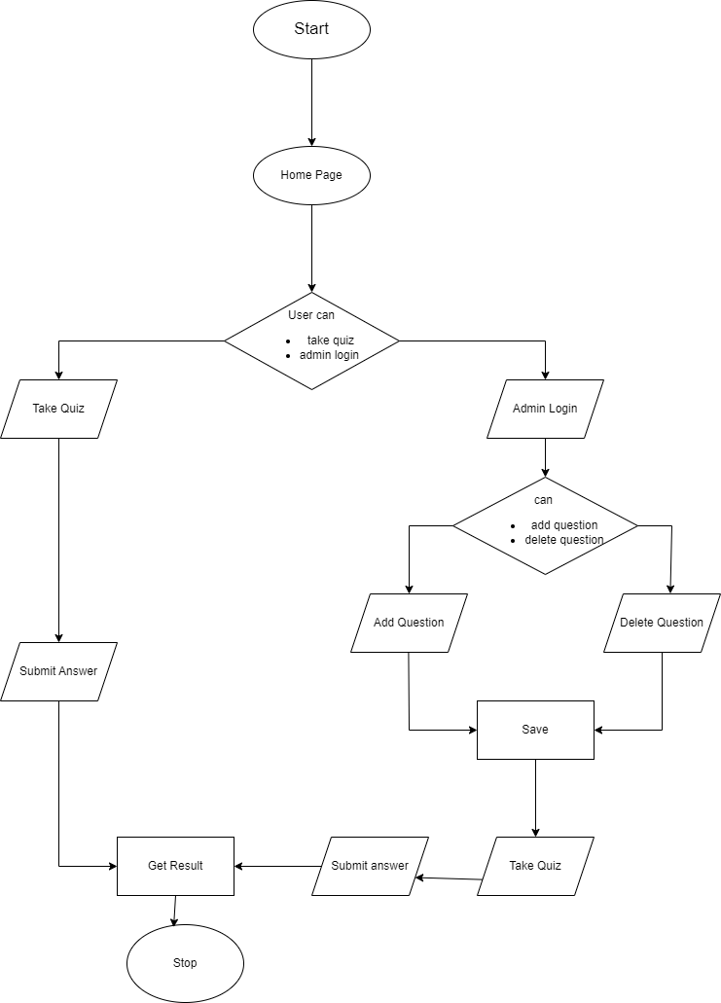

**UI screen shots**

**1. Main page**

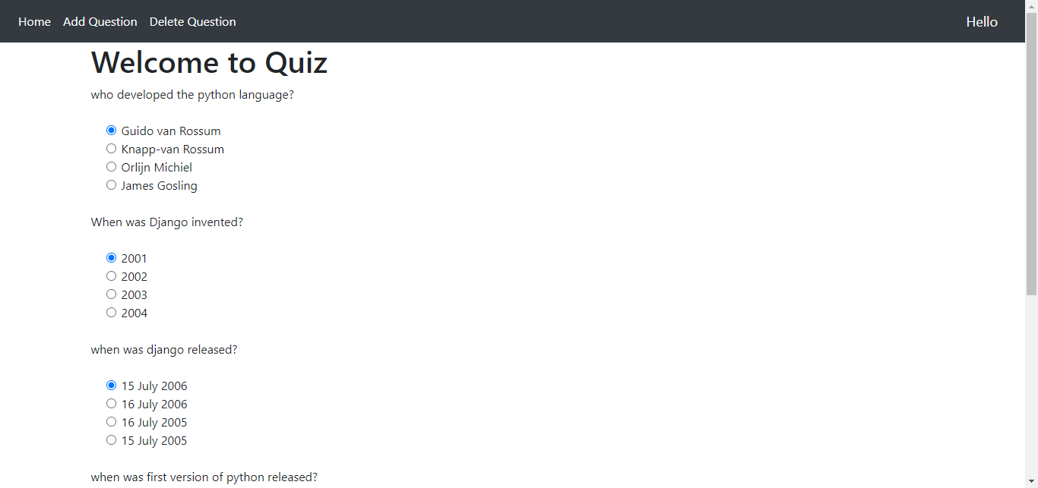

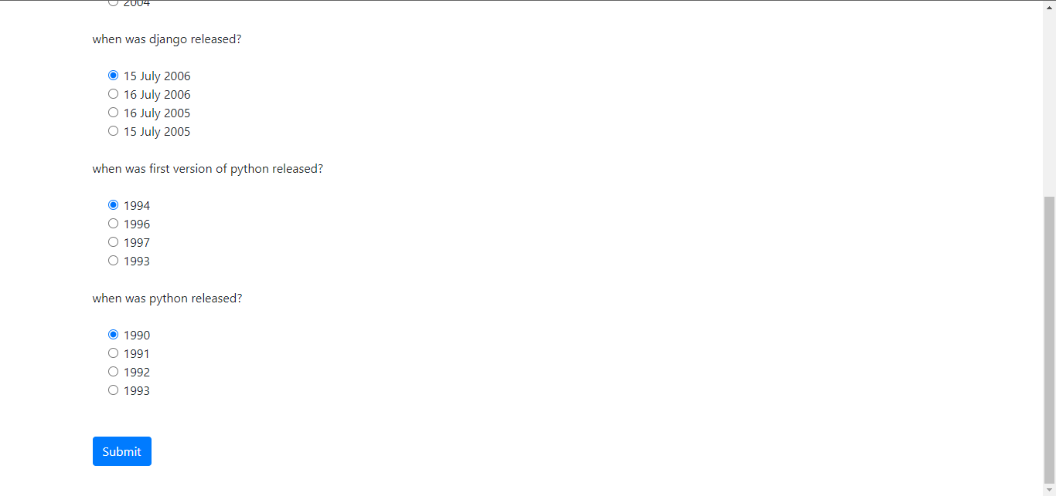

**2. Result page**

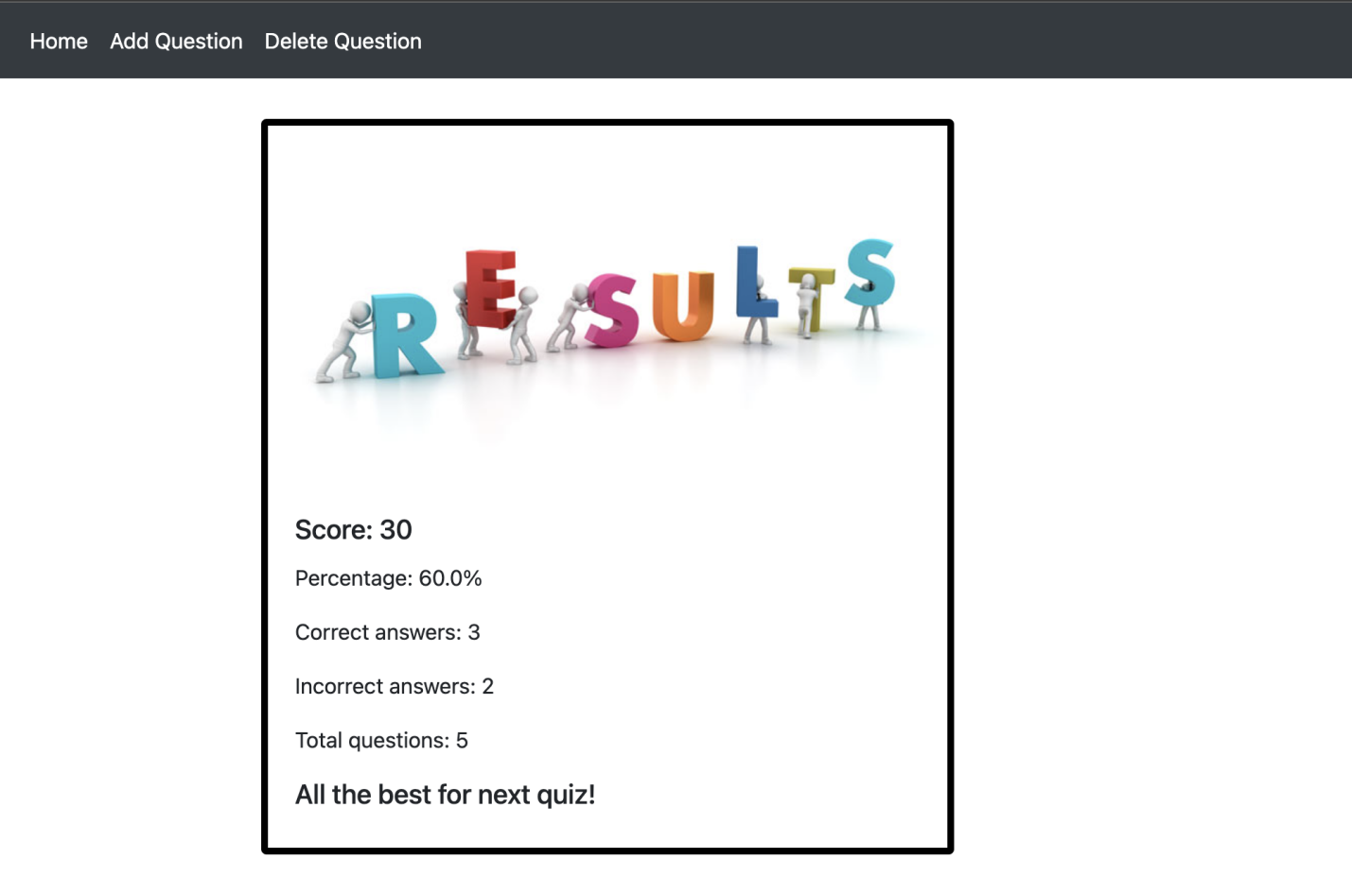

**3. Add Question page**

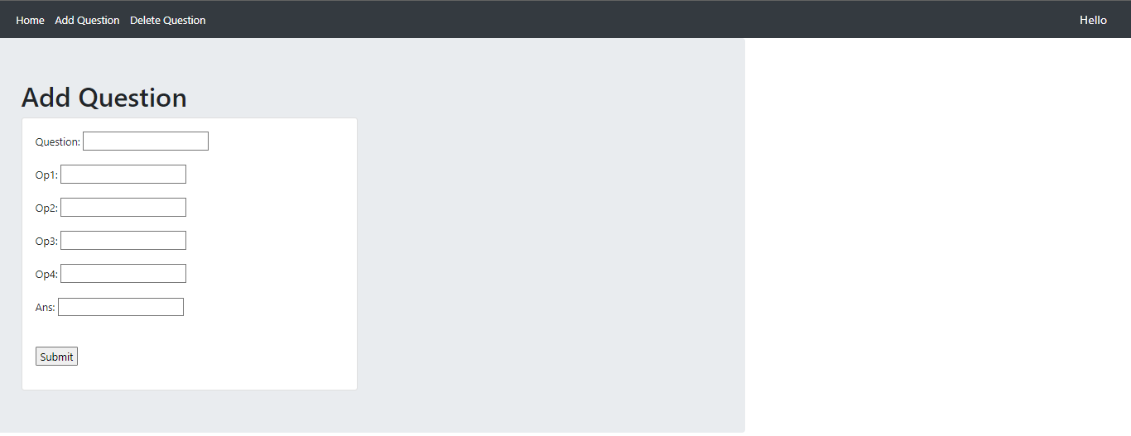

**4.Delete Page**

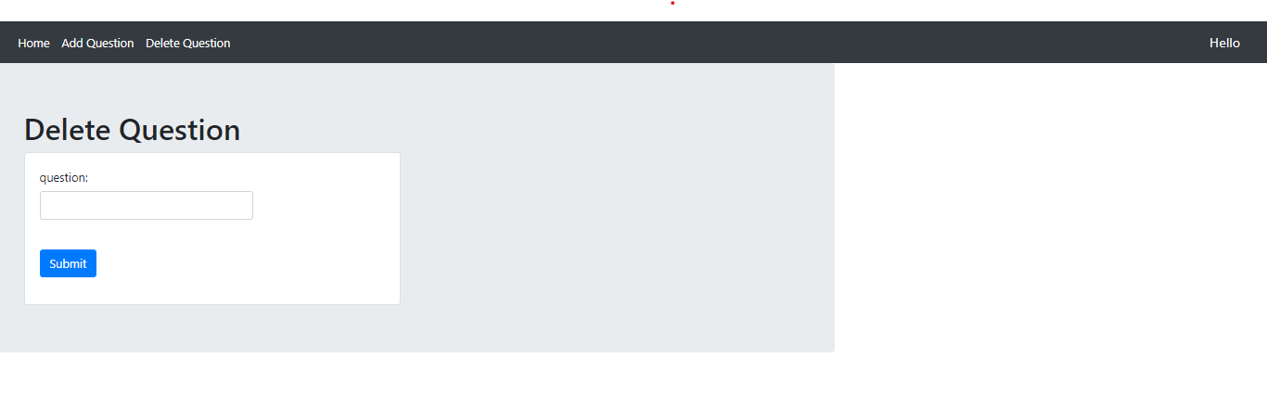

1. **Admin pannel**

